Intel Data Center Project
Energy Availability and Usage Analysis
Jeremy Joubert
8/3/2024
Introduction

- Project Overview: This project focuses on analyzing energy production, demand, and renewable energy sources to recommend an optimal location for Intel’s new data center. Co-designed with Intel's Sustainability Team, this analysis aims to identify regions with favorable energy characteristics. This was the final project in part two of The Global Career Accelerator Data Analytics Track, which primarily focused on Tableau. All images were taken directly from the Tableau Workbook submitted, which was graded 105%.

Visualizations

Net Production
- Objective: Identify regions that are net energy producers.
- Visualization: 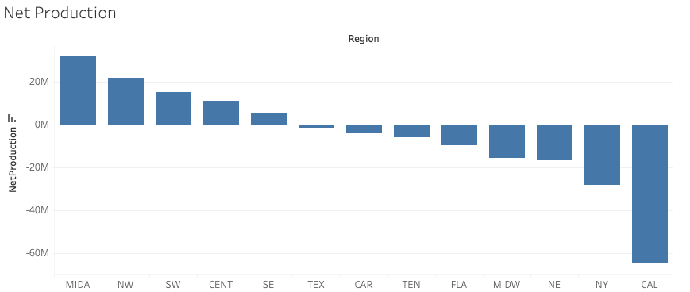

- Answer: The net energy producers are:
  - Mid-Atlantic
  - Northwest
  - Southwest
  - Central
  - Southeast
- Insights: The Net Production metric was obtained through creating a calculated field which subtracted the demand from the net generation as shown: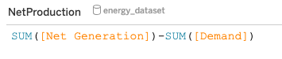
This approach made it so we can easily tell which regions are producing more energy than they are using, a valuable insight to have when deciding where to put a new data center.

Supply and Demand by Region
- Objective: Analyze fluctuations in energy production and demand over time.
- Visualization: 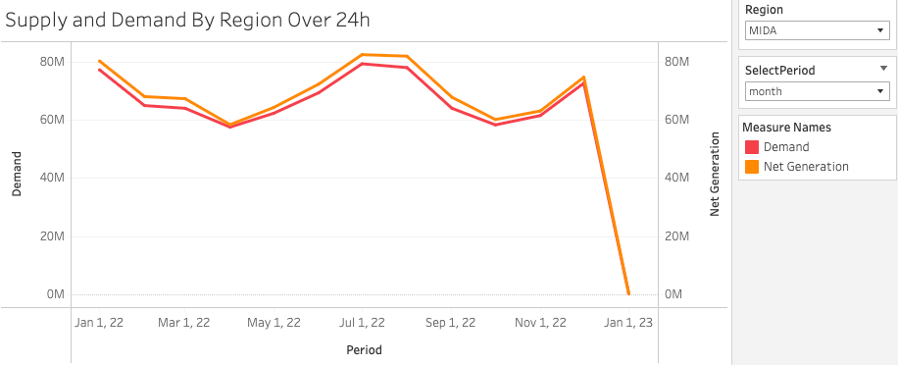
- Answer: The greatest energy surplus in the Mid-Atlantic region is observed in August, indicating a potential surplus in July.
- Insights: This visualization allows the user to select a region as well as time scale from drop down menus, displaying both the demand and net generation for the given selection. This allows easy interpretation of which months have a higher profit margin, which can give an idea of the stability for each region throughout a typical year when it comes to energy production and consumption metrics.

Renewable Energy
- Objective: Determine regions with the highest percentage of renewable energy.
- Visualization: 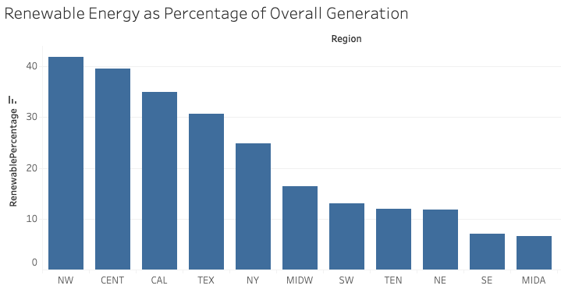
- Answer: The top 3 regions with the highest percentage of renewable energy are:
  - Northwest
  - Central
  - California
- Insights: Renewable energy was calculated from existing fields in the data as follows:
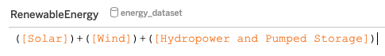
This was further processed to compute the percentage of energy coming from renewables from the designated region as follows:
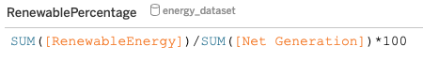
The result is an easy-to-read breakdown of the regions’ overall incorporation of renewable energies as compared to all other sources, another useful metric for the purposes of choosing a new data center location.

Utility Power Source Breakdown
- Objective: Display the energy source composition by region.
- Visualization: 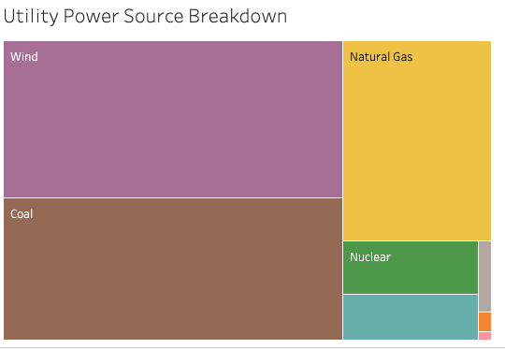
- Answer: The regions where renewable energy is the largest energy source are Central and Northwest.
- Insights: This visualization allows the user to select a region and then see the breakdown of energy sources, with the relative size of the colored areas corresponding to the percentage of energy derived from that particular source (Central region shown here). Being able to see those figures in a more digestible way facilitates an intuitive understanding of the region that will be a helpful supplement to our other charts and findings.

Hourly Difference in Generation
- Objective: Identify trends in energy generation throughout the day.
- Visualization: 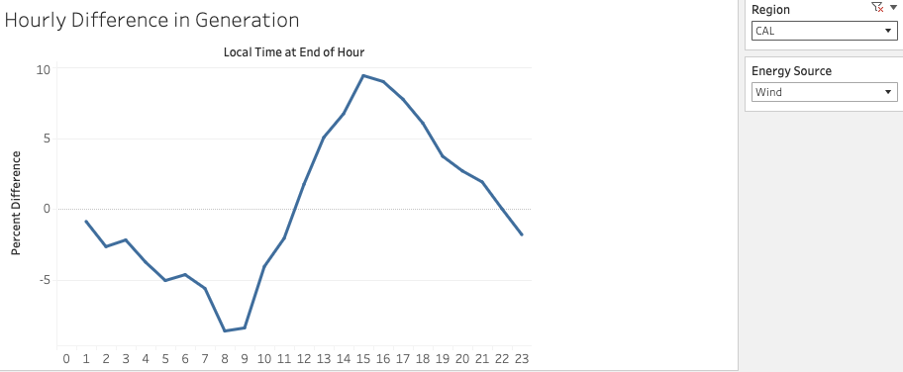
- Answer: California generates the most wind energy between noon and ten PM.
- Insights: This section allows the user to select a region as well as an energy source, and then displays the percentage of change from the past hour. If generation is increasing, we see a positive percentage value. This allows for an understanding of hourly trends in generation, which would be of use when coming up with the most efficient way(s) to source energy in any given region at any given time of day.

Energy Source by Region
- Objective: Compare the energy sources by region over time.
- Visualization: 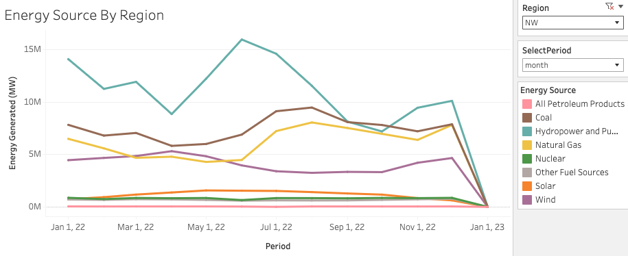
- Insights: Here we have a way to select a region and see the yearly trends as far as how much energy comes from which sources during which months. Having this information will be helpful in coming up with a plan to power the data center that will minimize strain on the existing energy infrastructure because we can clearly see what times of year are most burdensome for every individual energy source.

5. Recommendation
- Objective: Recommend a location for Intel’s new data center based on the analysis.
- Answer: The recommended region for Intel’s data center is the Central region. It offers a strong infrastructure for wind energy, a positive net energy gain, and lower population density, which contributes to stability and lower cooling costs. The Northwest is a notable alternative but has limitations due to environmental constraints.
Analysis: My recommendation would have to actually be the Central region. The Central region has a large and growing infrastructure set up for harnessing wind energy, along with a positive net energy gain. The low population density in this region means that there is not a whole lot of power draw, which also reduces the hourly fluctuations in power availability as compared to areas that provide power for major cities. The vastness of the terrain itself also makes this region a good location for a data center. A location in this region further north would likely be able to further reduce cooling costs associated with the center. Beyond that, the centrality of the region indicated in its namesake means that it would also be a good place to begin experimenting with the smart grid. Kansas certainly has some potential. The other notable candidate for this could be the Northwest, which also boasts a high percentage of renewable energy usage and an energy net positive. However, much of the land in this region is less resilient to human development due to the temperate forest designation. Even though sustainable practices are implemented, increased efficiency in these areas is still not enough to overcome the overall increase of energy usage that such a data center would bring about. That is to say, even though the land is productive, it is still a finite resource which cannot be overburdened. When we look at the hourly difference in generation, the Central region has a more stable trajectory with fewer peaks and valleys than does the Northwest. It is also likely that the wind generation capacity will continue to increase in coming decades. For these reasons, I suggest looking further into specific locales within the Central region and seeing if there may be other factors at play that might influence this decision.

